PROGRAMMING ASSIGNMENT- 2

(Submission deadline:13/11/2017)

Write a superclass called Person (as shown in the class diagram), which contains:

* Two instance variables name(String) and address (String).
* One constructor that initializes the name and address to the given values.
* Getter and setter for the instance variables as shown in class diagram.
* A toString() method that returns the name and address.

Write a test program to test all the methods defined in Person.

Write two subclasses of Person called Student and staff, as shown in the class diagram.

The Student class contains:

* Three instance variables program (String), year(int) and fees(double).
* One constructors as shown.
* Getter and setter for all the instance variables.
* Override the toString() method inherited, to return the name, address, program, year and fees.

The Staff class contains:

* Two instance variables school (String) and pay (double).
* One constructors as shown.
* Getter and setter for all the instance variables.
* Override the toString() method inherited, to return the name, address, school and pay.

Write a Test program to test all the classes created.

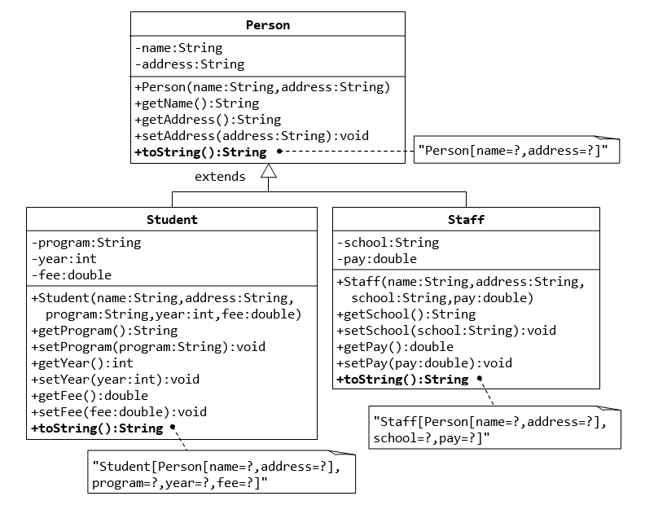

**Report Format**

**Section 0:** Cover page, include project title, student names and submission date

**Section 1:** problem description

**Section 2**: Problem Analysis

In this section, you should define your input variables, and their type. You should also define your output variables and their type. Use a table to summarize your answers.

**Section 3**: Solution Design:

In this section you should provide the UML class diagram

**Section 4**: Implementation:

In this section, you should list your complete Java Code. Make sure that your code is optimized for speed and efficiency.

**Section 5**: Evaluation

In this section, you should include a screenshot of your program’s output, based on the sample input provided in the previous page. Your output should be as close as possible to the solution provided in the previous page.

**Section 6**: Self-reflection

In this section, the following questions should be answered:

1. How did you work on the project?
2. What did you learn out of the project?
3. How much time did you spend working on the project?
4. And what is your personal opinion about the project?